

**MSc Materials Chemistry**

**Research Techniques PGT**

**Lab Manual**

**Semester 2**

**2023-2024**

If you require this document, or any other course material, in an alternative format e.g. large print, coloured paper, etc.,

please contact the CTO

(Chemistry.Teaching@ed.ac.uk, Tel. 0131 650 4754).

**Contacts**

**Course Organiser:** Dr David August David.August@ed.ac.uk, R282

**Course Administrator:** Zoe Burger chemistry.pgt@ed.ac.uk, CTO

**PGT Lab Technician**: Stewart Franklin stewart.franklin@ed.ac.uk, NG5

**Programme Director:** Dr Caroline Kirk caroline.kirk@ed.ac.uk, R284

**Introduction**  **3**

**Safety** **4**

**General Organisation**  **6**

**Marking and Assessment**  **9**

**Experiment 1A**: *Welcome to the Laboratory: Synthesis of a Ni(II) Complex* **12**

***Introduction***

**Aims**

The aim of the Research Techniques PGT laboratory course is to build upon the laboratory techniques covered in Semester 1 and further develop students independent research and laboratory skills. This course will also provide hands-on experience with a wide range of advanced analytical instrumentation that are commonly used in any modern chemical analysis. Students will also be introduced to practical computational skills and the significant role they play in modern research methods.

**Learning Outcomes:**

At the end of this laboratory course you will be able to:

1. **Manage available laboratory time effectively**

2. **Record analytical data in a professional manner**

3. **Use a range of advanced instruments & techniques**

4. **Utilise computational methods to support practical experiments**

5. **Appreciate the importance of safety in laboratory work**

6. **Act as a confident, proficient, and independent laboratory practitioner**

7. **Design and carry out novel investigations**

***SAFETY***

1. **In general, if you are uncertain about any safety matter, consult a demonstrator or a member of staff immediately, before carrying out any procedures.**

1. **Each experiment or instrument will have been assessed according to the ALL RISKS regulations by the technicians and staff members. These assessments will be available for your inspection and you are required to read them before each session.**

1. **Safety glasses must be worn at all times. Students who normally wear spectacles are required to wear safety glasses over their normal spectacles, or to obtain a pair with toughened glass or plastic lenses and side shields. Students who wear contact lenses should advise the Technicians and/or Couse Organiser.** Contact lenses pose a particular hazard as any liquid entering the eye will penetrate behind the lens and irrigation is almost impossible. It is therefore imperative that contact lens wearers should take extra precautions to prevent chemicals from entering the eye. These precautions include the requirement to wear goggles for any experiment that may involve a significant risk of harmful chemicals splashing into the eyes. This requirement, where necessary, will be indicated on the appropriate risk assessment form. Wearers of contact lenses should preferably wear spectacles (and over-glasses) as an alternative while in the laboratory. However, if lenses are to be worn, the student **MUST** make themselves known to the technician at the beginning of the laboratory course.

1. **Students must bring their own laboratory coat which must be worn at all times when in the laboratory.** **Lab coats should be stored in the laboratory when not in use.**

1. **Smoking, eating and drinking are not permitted at any time.**

1. **Coats and bags must not be kept on the laboratory floor, as they obstruct the gangway. Lockers for use during the laboratory periods are provided in the PGT Study Room. Students are advised to bring a padlock if they wish to leave valuables in theselockers.** **All possessions are left at your own risk.**

1. **Remember that you are responsible for your own safety and for the safety of others working in the laboratory.**

1. **Take the utmost care in disposing of hazardous chemicals - when in doubt consult the member of staff. Do not dispose of organic solvents down the sink. Place such residues in the appropriate containers provided – yellow cap for chlorinated, red cap for non–chlorinated.**

1. **If you suffer from any medical condition or disability that might affect your safety or that of others in the laboratory, please inform discreetly the member of staff in charge of the laboratory.**

1. **Never work in the laboratory except during approved class hours unless specifically arranged with the course organiser.**

**Emergencies**

* + The first rule in any emergency is to alert the member of staff, a technician, or a demonstrator.
  + Report all accidents requiring First Aid (cuts, burns etc.)
  + Small fires can be smothered with a wet duster. Report all larger fires immediately.
  + If chemicals are splashed into the eyes or face, immediate action is required. Eyewashes are provided at each end of the laboratory, and you should familiarise yourself with their use.
  + Chemicals on the hands or clothes should be rinsed with water immediately.
  + If the fire alarm sounds (a continuous alarm), the laboratory must be evacuated immediately. There are fire exits at both ends of the laboratory; you should be escorted by your demonstrator to the assembly point, which is beside Brewster’s statue at the front door of the old building. If an intermittent alarm sounds, the problem is in the other building and evacuation is not necessary.
  + The nearest qualified first aid workers are:

Alan Taylor (Lab 10 – Mass Spec), Ilka Schmueser (Lab 6/73) or Jennifer Anderson (Inorganic Lab).

***General Organisation***

**Laboratory Timetable**

The Research Techniques PGT course will operate in weeks 1-10 of Semester 2. Each student will be scheduled to attend 2 sessions each week. You must attend your assigned sessions only and you must complete all of the investigations and workshops. The sessions will take place in multiple locations – please see the full timetable on LEARN for details.

**Labs for the Materials Chemistry PGT programme will run Mondays from 10 am to 1 pm (10:00-13:00) and Thursdays 2 pm to 5 pm (14:00-17:00).**

The Laboratory schedule consists of three sections:

* Section 1 is a 2-week rotation of four instrument training sessions. These are designed to give you hands-on training and experience with a range of advanced analytical instrumentation. This is intended to prepare you for the later investigation and your summer research projects.
* Section 2 consists of a short 2-week computational chemistry workshop and project designed to introduce you to aspects of computational chemistry that can be applied to Analytical chemistry. Computational techniques are rapidly increasing in importance in chemistry and are becoming an essential practical skill for any modern chemist.
* Section 3 is a stand-alone investigation spanning a total of 12 lab sessions. During this period, you will work in groups to investigate an aim utilising a range of laboratory techniques and analytical instruments. This builds on your experience in Semester 1 and aims to prepare you thoroughly for your summer research projects.

Throughout this course you be assigned to groups that will rotate around each of the experiments. The composition of the groups will appear on LEARN before the start of the lab. **Please note, the group assignments may change for each of the different sections.**

|  |  |  |
| --- | --- | --- |
| **Week** | **Section** | **Location** |
| **Week 1-2** | Session 1: Instrument Training | ACIS Lab |
| **Week 3-4** | Session 2: Computational Techniques | To be confirmed |
| **Week 5-10** | Investigation B: High Tc Superconductor | ACIS Lab & Physical Lab |

**Attendance**

An attendance register will be strictly kept and monitored for both Safety and Visa conditions. If you are absent from, or miss a substantial part of, a particular session, please inform the lab organiser Dr David August ([David.August@ed.ac.uk](mailto:David.August@ed.ac.uk)) as well as the lab technicians Stewart Franklin ([stewart.franklin@ed.ac.uk](https://uoe-my.sharepoint.com/personal/daugust2_ed_ac_uk/Documents/PGT%20-%20Courses/2023-24%20Timetabling/Course%20Documents/2023-24%20Lab%20Manuals%20-%20DA%20Working%20Copies/stewart.franklin@ed.ac.uk)) or Alba Navarro Rodriguez ([??](https://uoe-my.sharepoint.com/personal/daugust2_ed_ac_uk/Documents/PGT%20-%20Courses/2023-24%20Timetabling/Course%20Documents/2023-24%20Lab%20Manuals%20-%20DA%20Working%20Copies/stewart.franklin@ed.ac.uk)) as soon as possible. See below for information regarding deadline extensions and Special Circumstances.

**Demonstrators and staff**

Postgraduate demonstrators will be available at all sessions. They will instruct you in experimental techniques and provide guidance on the analysis of results. Please make use of them – they are all experienced PhD researchers within the School and have a lot of knowledge to share.

The Research Techniques PGT organiser is **Dr David August (Room 282), Tel. 0131 650 4818, E-mail: David.August@ed.ac.uk**

Expert technical support in the laboratory is provided by theACIS technician **Alba Navarro Rodriguez** ([??](https://uoe-my.sharepoint.com/personal/daugust2_ed_ac_uk/Documents/PGT%20-%20Courses/2023-24%20Timetabling/Course%20Documents/2023-24%20Lab%20Manuals%20-%20DA%20Working%20Copies/stewart.franklin@ed.ac.uk))

**Preparation**

You are asked to read the instructions for each session and view any supporting material posted on LEARN **BEFORE** attending the associated session. This will enable you to follow the practical procedures described, minimising risk and the likelihood of damage to expensive equipment. **If you are unsure about anything, please consult a member of staff, or a demonstrator BEFORE continuing.**

***Marking and Assessment***

The importance of laboratory work in the Chemistry Degree Courses cannot be overemphasised. The laboratory classes are therefore an integral part of the course and **attendance at them is compulsory. Attendance at each designated session is recorded.**

**Poor marks are invariably the result of poor attendance and/or failure to submit reports, rather than of poor performance at the bench.** Attendance and marks are therefore monitored throughout the year. Should you miss *any* laboratory class for medical reasons you must notify the Lab Organiser by e-mail to Dr David August at [**David.August@ed.ac.uk**](mailto:David.August@ed.ac.uk) who will advise on any alternative arrangements.

To pass this laboratory course you need a minimum score of 50%. To pass the taught component of the MSc, you must both 1) obtain ≥50% in 4 out of the 6 courses and 2) maintain an average grade of ≥50% across all six courses. Please see the Programme Handbooks for further information.

## Late Penalties

All assessment items will be subject to late penalties and a 5% mark penalty will be applied for every day over work is submitted after your agreed deadline. Information on the course deadlines can be found on LEARN and information regarding extension requests and Special Circumstances can be found below.

## Plagiarism

According to the University’s Examination Regulations and Guidelines: ***"Plagiarism*** *is defined as the submission by a candidate, without adequate acknowledgement, of any piece of work (e.g. results, report, written assignment, examination answer) which has been copied from the work of another person or persons. This is a* ***serious offence*** *and if detected will result in the severest penalties. It should be understood that compiling an essay by 'lifting paragraphs' from other sources (e.g. a book, the web) is an example of plagiarism. You are strongly advised to read the information given at www.aaps.ed.ac.uk/regulations/Plagiarism/Intro.htm and the web pages listed therein ".*

**Course Assessment**

This course includes a range of different assessment methods to evaluate your understanding of the methods and skills detailed in the learning outcomes as well as your ability to operate as a research scientist. Each section of the course is assessed separately and contributes varying amounts to the total course grade as detailed below.

|  |  |  |
| --- | --- | --- |
| **Section** | **Assessment** | **Percentage of Course Grade** |
| **1** | Online Multiple-Choice Quizzes | 20% |
| **2** | Computational Exercise | 20% |
| **3** | Chem. Comm. Paper Report | 50% |
| **3** | Lab Notebook | 10% |

**Types of Assessment**

* Section 1 will be assessed using a series of short online multiple-choice quizzes. This will include a short practice quiz to help get you used to the system. **Only one attempt is allowed per student per quiz** and **you must complete the quiz in one sitting**. Please make sure you have time before starting – each quiz should not take more than 30 mins. If you experience any difficulties completing a quiz – please notify the course organiser.
* Section 2 is assessed through an individual project carried out during session 4, followed by independent work, and written into a short report.
* Section 3 requires an Investigation report written in the form of an RSC Chemical Communications Paper. Details on the format and marking criteria can be found on LEARN and at the end of this document. In addition, you will also be assessed your lab book record-keeping. Further guidance on this can be found within the Investigation details.

**Recording your Methods and Results**

Recording the results and details of experimental procedures is an important part of all laboratory work. You must do as much as possible of this in the laboratory, using the lab notebook to avoid forgetting anything, but some may have to be done in your own time soon after the lab session. The major things to record are:

* **What you did** (substances, quantities, times, temperatures, simulation parameters, etc.). This includes instrument details and specific information on the set up and methods used.
* **What you observed and measured.** This could be physical observations, such as colour changes, or references to samples submitted. This will also include saving and cataloguing any data you collect.
* **What you deduced from your observations.** This may be notes to begin with, but these will eventually form the basis of you reports.

Your lab notebook will be graded during the final weeks of Investigation B and forms 10% of your final course grade. Marking criteria are available on LEARN. **Please make sure you record all of your observations in English.**

**Extensions and Special Circumstances**

Under University policy, you can apply for an extension of up to 3 days for any of the assessment exercises. You’ll need to describe the situation that has affected you and your studies, including the time you were affected and your symptoms. You can find out more and apply for an extension online here: [Extensions Explained](https://www.ed.ac.uk/student-administration/extensions-special-circumstances/students/extensions-explained). You must submit requests for these extensions BEFORE the assessment deadline.

You can also apply for Special Circumstances for any aspect of this course. You should apply for Special Circumstances if a significant life event means that you require more than a 3-day extension to complete your work, or if your situation is long-term. Special Circumstances can allow you a longer extension, it can mean late penalties are removed, or it can even result in some sections of your assessment being disregarded from your overall course mark. In the online application form you’ll need to explain the situation that affected you in detail, including when you were affected, and describe the negative impact on you and your academic work. You’ll also need to attach a supporting letter, like a letter from your doctor or a counsellor or a member of staff (if they’ve been aware of your situation).

You can read more and apply online here: [Special Circumstances Explained](https://www.ed.ac.uk/student-administration/extensions-special-circumstances/students/special-circumstances-explained).

In either case, please contact Student Support ([chemistry.studentsupport@ed.ac.uk](https://uoe-my.sharepoint.com/personal/daugust2_ed_ac_uk/Documents/PGT%20-%20Courses/2023-24%20Timetabling/Course%20Documents/2023-24%20Lab%20Manuals%20-%20DA%20Working%20Copies/chemistry.studentsupport@ed.ac.uk)) who can assist with your application an provide further guidance.

**Instrument Training Exercises**

**Section Timetable**

For this section, the class will be divided into 4 groups. Each group will be assigned to a different instrument for each lab session – rotating each new session until everyone has completed all the topics**. Please see LEARN for the group allocations.**

|  |  |  |
| --- | --- | --- |
| **Number** | **Topic Title** | **Location** |
| **1** | XRF | ACIS Lab |
| **2** | SEM | ACIS Lab |
| **3** | Fluorimeter/IR or NMR | ACIS Lab |
| **4** | Reitveld Refinement | Lyon Playfair Computer Suite |

|  |  |  |  |  |
| --- | --- | --- | --- | --- |
| **Session** | **Group A** | **Group B** | **Group C** | **Group D** |
| **Mon 15th Jan 10-13:00** | Topic **1** | Topic **2** | Topic **3** | Topic **4** |
| **Thu 18th Jan 14-17:00** | Topic **2** | Topic **3** | Topic **4** | Topic **1** |
| **Mon 22nd Jan 10-13:00** | Topic **3** | Topic **4** | Topic **1** | Topic **2** |
| **Thu 25th Jan 14-17:00** | Topic **4** | Topic **1** | Topic **2** | Topic **3** |

**General Instructions**

For each lab session in this section, you will receive guidance and training in operating your assigned instrument. This is very similar to the training that any new researcher would receive when using these instruments for the first time. The training should take approx. 1-2 hours. Please use the remainder of the lab session to try operating the instrument yourselves using the test samples provided.

Remember to record all the information provided to you in your lab notebook. You need to keep detailed enough records that you can refer to them if and when you next use the instrument.

**Topic 1: X-ray Fluorescence Spectroscopy (XRF)**

**Learning Outcomes:**

* Explain the principles of X-ray Fluorescence spectroscopy (XRF) and its applications.
* Know how to operate an XRF instrument – including sample preparation, spectral acquisition and data analysis.
* Describe and troubleshoot common instrument failures.

**Pre-lab:**

Read through the information below **BEFORE** attending the associated lab session.

In addition, you must complete the require radiation safety training before attending this session. All details for how to do so can be found on LEARN.

**Introduction:**

X-ray Fluorescence Spectroscopy (XRF) is a powerful and non-destructive analytical technique widely employed for elemental analysis in diverse fields such as geology, chemistry, environmental science, archaeology, and materials science. XRF allows for the identification and quantification of elements present in a sample by measuring the characteristic X-rays emitted when the sample is exposed to high-energy X-ray radiation. The technique relies on the phenomenon of inner-shell ionization, where X-rays excite inner-shell electrons of atoms in the sample, leading to the ejection of these electrons and the subsequent emission of characteristic X-rays as the electrons transition to lower energy levels. By detecting and analysing the energy and intensity of these emitted X-rays, XRF provides valuable insights into the elemental composition of a wide range of materials, enabling researchers and analysts to unravel the chemical makeup of substances with high precision and speed. XRF's non-destructive nature and ability to analyse solid, liquid, and powdered samples make it an indispensable tool for both qualitative and quantitative elemental analysis in numerous materials applications.

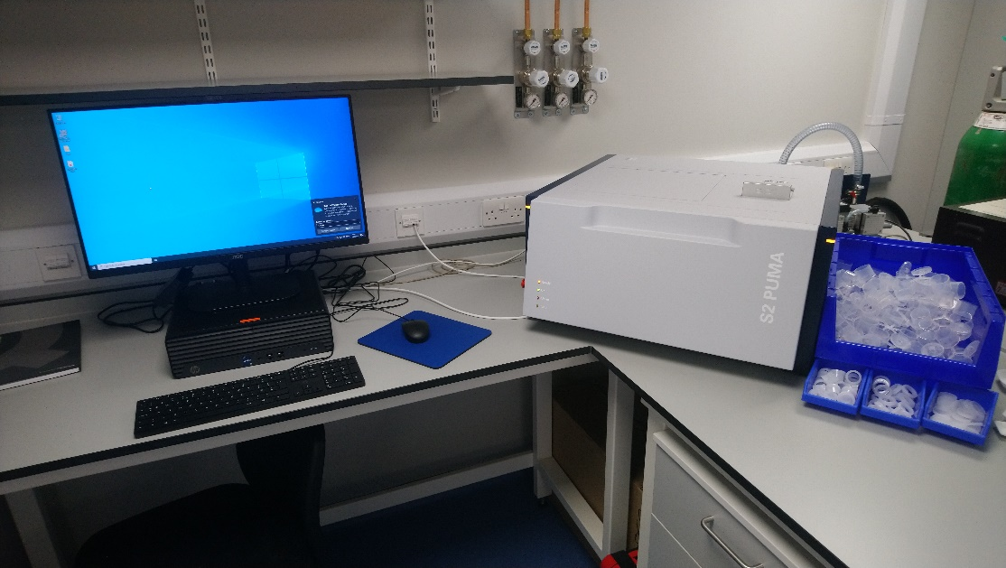

**Figure 1.** The Bruker S2 PUMA XRF spectrometer available in the ACIS lab.

**Safety:**

Hazards associated with this exercise and the XRF instrument are listed in the Risk Assessment Form available on LEARN.

This instrument utilises high energy radiation in the form of X-rays. Whilst the equipment is designed with numerous safety and interlock systems to prevent users from accidental irradiation, all users should complete the School of Chemistry’s radiation safety training before using this instrument.

**Instrument Walk-Through:**

1. **Instrument Overview:**

* Familiarize users with the components of the XRF system, including the sample stage, X-ray source and the software interface.
* Introduce the basic principles of XRF and how the emission of characteristic X-rays can be used to analyse the elemental composition of samples.

2. **Safety Precautions:**

* Emphasise safety measures, including proper handling of chemical samples and the risk of radiation exposure.
* A reminder that lab coats and safety glasses should be worn at all times.

3. **Powering On and System Check:**

* Demonstrate the proper procedure for turning on and logging into the XRF system.
* Explain the how to check that the system is operating correctly.

4. **Sample Preparation:**

* Instruct users on sample preparation. Provide guidance on the required sample quantities, fitting and loading samples into the samples stage area and guidance on grinding powdered samples if sample homogeneity is required.

5. **Instrument Calibration:**

* Demonstrate how to calibrate the instrument using certified reference materials.

6. **Sample Submission:**

* Instruct users on how to insert and align samples, select appropriate measurement conditions (e.g. voltage, current) and acquire a spectrum.

7. **Data Analysis:**

* Demonstrate how to analyse the collected data and identify elements present in the sample based on characteristic X-ray peaks.
* Discuss the quantification of elemental concentrations using calibration curves.

8. **Maintenance and Troubleshooting:**

* Offer guidance on common troubleshooting issues and when to contact the ACIS Instrument Technician. Common issues include ??.

9. **Documentation:**

* Stress the importance of maintaining a record of method parameters, sample details, and obtained spectra. These should all be recorded in lab notebooks and any data copied over to personal devices via a USB memory stick.

**Test Samples:**

Test sample details – to be added.

“I think they might be able to try one powder sample and one liquid sample, as the different densities of the samples are likely to yield noticeable differences with their backgrounds and I feel like it is good for beginners to learn it for x-ray technology. Regarding the sample, I suggest choosing two commercial metal oxides mixed based on the mass ratio for the powder sample, and similarly, two commercial metal salts mixed in water according to mass concentration for the liquid sample.”

**Assessment:**

Complete the associated multiple-choice quiz on LEARN.

**Further Support:**

The full instrument manuals are available on LEARN. You are not expected to read these in full, however, please use these as reference if you wish to know any more about the instruments or refresh your memory of how to operate them.

**Topic 2: Scanning Electron Microscopy (SEM)**

**Learning Outcomes:**

* Explain the principle of Scanning Electron Microscopy (SEM).
* Compare and contrast the benchtop SEM with other similar imaging techniques and SEM instruments.
* Know how to operate a SEM instrument – including sample preparation, imaging methods and data analysis.
* Describe and compare the different detection methods available – including back scattered and secondary electrons.
* Describe and troubleshoot common instrument failures.

**Pre-lab:**

Read through the information below **BEFORE** attending the associated lab session.

**Introduction:**

Scanning Electron Microscopy (SEM) is a powerful analytical technique used for imaging substances at far higher magnifications than a standard optical microscope, enabling researchers to explore intricate details of surfaces at magnifications up to hundreds of thousands of times. The principle behind SEM involves scanning the sample with a finely focused electron beam, generating signals such as secondary electrons and backscattered electrons. These signals are then detected and translated into highly detailed images and compositional information.

As air interferes with the beam of electrons, all SEM instruments require an ultra-high vacuum chamber in which the samples are placed. Traditional SEM instruments have large vacuum chambers that require hours to pump down and changeover samples. The SEM in the ACIS lab is a modern bench top instrument. The vacuum chamber is only a centimetre across and therefore, samples can be loaded and unloaded rapidly.

Whilst SEM instruments can image almost any solid samples, in many cases, a degree of sample preparation is required. The main issue is due to the powerful electron beam inducing a charge within insulating samples – leading to an effect called “charging”, resulting in glaring white patches in the images. To avoid this, and prevent damage to the sample, many samples are coated with a very thin layer of a conductive material – usually gold or palladium.

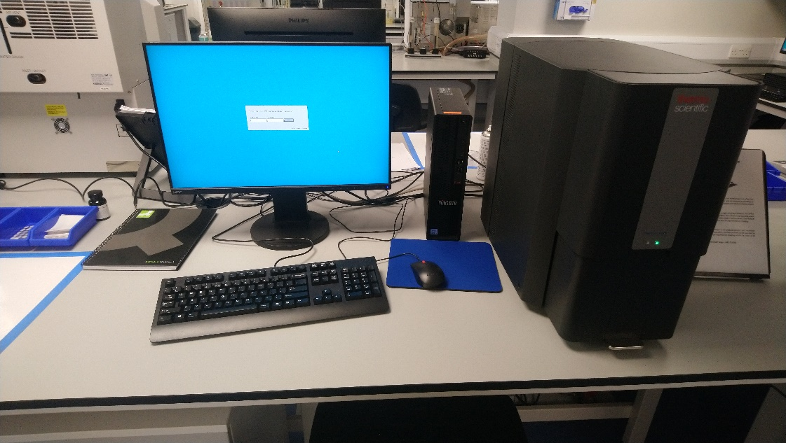

**Figure 2.** The ThermoScientific Phenom G6 Pure SEM spectrometer available in the ACIS lab.

**Safety:**

Hazards associated with this exercise and the SEM instrument are listed in the Risk Assessment Form available on LEARN.

**Instrument Walk-Through:**

1. **Instrument Overview:**

* Familiarize users with the components of the SEM system, including the sample chamber, detectors, and control interface.

2. **Safety Precautions:**

* Emphasise safety measures, including proper handling of solvents and chemicals.
* Wear personal protective equipment, such as lab coats and safety glasses at all times in the ACIS facility.

3. **Powering On and System Check:**

* Demonstrate the proper procedure for turning on the SEM system.

4. **Sample Preparation:**

* Provide guidelines on mounting samples onto the stubs provided. Discuss the limitation of the instrument and need to have flat, secure samples to avoid contaminating the aperture.
* Instruct users on the different holders available including the standard and anti-charge versions.
* Explain and demonstrate gold sputter coating as a method for preventing sample charging.

5. **Image Acquisition:**

* Understand the basics of acquiring high-resolution images using the SEM.
* Adjust imaging parameters such as accelerating voltage, working distance, and scan speed.

6. **Navigation and Stage Control:**

* Use the stage controls to navigate and position the sample for imaging.
* Understand how to locate specific regions of interest on the sample.

7. **Data Analysis:**

* Explain how to analyse and interpret SEM images using relevant software.
* Demonstrate basic image processing and measurement tools.
* Maintain detailed records of experimental conditions, settings, and any deviations encountered during analysis and save files in appropriate and named folders.

8. **Maintenance and Troubleshooting:**

* Offer guidance on common troubleshooting issues and when to contact the ACIS Instrument Technician. Common issues include charging and poor image quality due to aperture misalignment.

**Test Samples:**

Test sample details – to be added.

**Assessment:**

Complete the associated multiple-choice quiz on LEARN.

**Further Support:**

The full instrument manuals are available on LEARN. You are not expected to read these in full, however, please use these as reference if you wish to know any more about the instruments or refresh your memory of how to operate them.

**Topic 3: Nuclear Magnetic Resonance (NMR) Spectroscopy**

**Learning Outcomes:**

* Explain the principles of solid-state NMR spectroscopy.
* Compare and contrast different NMR instruments and identify which instruments are suitable for solid state measurements.
* Know how to operate an NMR instrument for the submission of solids – including sample preparation, sample submission and data analysis.
* Describe and troubleshoot common instrument failures.

**Pre-lab:**

Read through the information below **BEFORE** attending the associated lab session.

**Introduction:**

Nuclear Magnetic Resonance Spectroscopy (NMR) is a powerful analytical technique used for the identification and quantification of pure compounds and complex mixtures. The School of Chemistry is fortunate to be equipped with a dedicated NMR suite including the following instruments.

* **1 x 300 MHz solid-state instrument equipped with a 4 mm WB MAS broadband probe, available for 13C, 15N, 31P, 11B and various X nuclei, with spin rates of up to 12.5 kHz.**
* 1 x 400 MHz instrument (AVA400) equipped with a TBO room temperature probe available for 1H and all X nuclei.
* 2 x 500 MHz instrument. One (PRO500) is equipped with a broad band Prodigy cryo-probe and available for 1H and all X nuclei. The other (AVA 500) is equipped with a BBO cryoprobe available for 1H and all X nuclei.
* 1 x 600 MHz instrument equipped with a QCI cryo-probe and available for 1H, 13C, 15N and 19F only.
* 1 x 800 MHz instrument equipped with multiple probes that are changed occasionally. The most regular is a TCI cryoprobe available for 1H, 13C and 15N only. This instrument usually reserved for specialist samples including protein structure elucidation and the analysis of complex mixtures.

Many of you will already have completed the NMR introductory courses and workshops in Semester 1, but in summary, NMR is a powerful technique for elucidating the structure of compounds in solution. By applying a strong magnetic field, all nuclei with spin ≠ 0 are placed into two or more possible states. As a form of spectroscopy, the application of radio frequencies then allows us to probe the differences in these energy levels. Since the energy differences experienced by the nuclei are small and highly dependent on their local environment, this allows us to extract a lot of information about the chemical structures.

The majority of NMR samples are submitted as a liquid or in solution. This is partly due to the ease of sample preparation but is also due to the inherent rotation and movement of molecules in solution that simply the NMR spectra. However, when solid samples are required, this is not the case and the various anisotropic interactions (such as dipolar interactions) are no longer averaged to zero.

One approach used to minimise or remove the spectral effects of these anisotropic interactions is Magical Angle Spinning (MAS). When the sample is rotated rapidly at the magic angle (54.74°), many of the anisotropic interactions are averaged out either partially or completely. The only spectrometer currently capable of running solid samples is the 300 MHz instrument.

You will cover far more on the theory of solid-state NMR in the associated lecture course later this semester. For now, this lab will introduce you to the instrument, sample preparation and submission as well as the practical skills required for obtaining solod-state NMR spectra.

**Figure 3.** The Bruker 300 MHz MAS NMR spectrometer available in the School’s NMR suite.

**Safety:**

Hazards associated with this exercise and the NMR instruments are listed in the Risk Assessment Form available on LEARN.

Please note, the instruments operated during this lab contain very strong magnetic fields. Your demonstrator will advise further on the day, but please avoid taking any metallic objects close to the instruments – this includes watches, keys and credit cards.

**If you have any medical devices or implants – such as pacemakers, hearing aids or metal pins – please alert your demonstrator to this as soon as you can and do not enter the NMR room.**

**Instrument Walk-Through:**

1. **Instrument Overview:**

* Familiarize users with the components of the NMR system, including the magnet, probe, console, sample loader and the software interface.
* Introduce the different types of NMR instruments and their applications.
* Talk through the NMR information board, and how to choose the best instrument for the task. NOTE: NMR suite closed every Wednesday morning for liquid nitrogen refills.

2. **Safety Precautions:**

* Emphasize safety measures, including proper handling of chemicals and cryogens.
* Remind students of the dangers associated with strong magnetic fields.
* Provide guidelines for using personal protective equipment including wearing safety glasses when submitting or retrieving samples. No lab coats are to be worn in the NMR suite.

3. **Sample Preparation:**.

* Instruct users on sample preparation including the filling of MAS rotors and choosing an appropriate size.
* Show how to place the samples within the spectrometer.

4. **Sample Submission:**

* Run through the sample submission process including logging in, sample position selector, experiment selection, night/day experiments and user details

5. **Data Analysis:**

* Provide introductory training on using the NMR software for data acquisition.
* Demonstrate how to interpret the NMR data, including peak position, peak integrals and splitting patterns using the TopSpin software. Students should be familiar with MNova, but additional guidance on this software is available on LEARN if required.

6. **Maintenance and Troubleshooting:**

* Offer guidance on common troubleshooting issues and when to contact the NMR Technicians using the bell provided. Common issues include…

7. **Documentation:**

* Stress the importance of maintaining a detailed record of any NMR samples run, including sample details and acquired spectra. These should be recorded in lab notebooks and any data copied over to personal devices from the NMR archive.

**Test Samples:**

Test sample details – to be added.

**Assessment:**

Complete the associated multiple-choice quiz on LEARN.

Further Support:

Further information on the general theory and uses of solution state NMR can be found in the notes from the Semester 1 Introduction to NMR course. Further theory on solid-state NMR will be covered in detail later in Semester 2. Advice and guidance on downloading and using the NMR software MNova can be found on LEARN.

**Topic 3:** **Fluorescence and Infrared (IR) Spectroscopy**

**Learning Outcomes:**

* Explain the principle of Fluorescence Spectroscopy and Infrared (IR) Spectroscopy
* Compare and contrast these techniques with UV/Vis spectroscopy.
* Know how to operate a fluorescence spectrometer (or fluorimeter) – including sample preparation, spectral acquisition, lifetime measurements and data analysis.
* Know how to operate a Infrared (IR) spectrometer – including sample preparation, spectral acquisition and data analysis.
* Describe and troubleshoot common instrument failures.

**Pre-lab:**

Read through the information below **BEFORE** attending the associated lab session.

The fluorimeter utilises pulsed LASERS when acquiring lifetime measurements. Whilst the LASER is bolted to the instrument and protected by interlocks when in use, it can in theory be removed and changed over. Therefore, all users must complete the required School LASER safety training **BEFORE** using the instrument.

Links to the training can be found on LEARN.

**Introduction – Fluorescence Spectroscopy:**

Fluorescence spectroscopy is a powerful analytical technique used for exploring the interaction between light and fluorescent molecules, shedding light on their structure, composition, and dynamic behaviour. The ACIS lab is equipped with an Edinburgh Instruments FS5 fluorimeter.

Unlike UV/Vis spectroscopy, that explores only the absorption of light, fluorescence spectroscopy explores the absorption and emission of light from fluorescent samples. How much, for how long, and at what wavelength the light is emitted can provide valuable insights into the molecular environment. One of the main advantages of fluorimetry is its sensitivity – with most samples operating well into or below micromolar concentrations. This is primarily due to the fact that many compounds do not emit light, and therefore, there is considerably less background noise compared with other spectroscopic techniques.

Fluorescence spectroscopy can provide a huge amount of information on the electronic transitions within a compound. This is particularly important for the development of new photocatalysts and solar cell dyes where care must be taken to match energy levels. Fluorescence spectroscopy can also be used to explore the molecular environments due to the high distance dependence of many quenching or energy transfer process. This lends itself to many biological probes where fluorescent tags can used to explore protein folding pathways or detect specific process in live cells. The latter can be utilised with a Fluorescent plate reader to run biological assays – also available within the ACIS suite.

**Introduction – Infrared Spectroscopy:**

Infrared (IR) spectroscopy relies on the absorption of infrared radiation due to molecular vibrational and rotational modes. Specific absorption bands can be used to identify or exclude key functional groups with a sample and the fingerprint-like spectra generated at lower wavenumbers can be compared with spectral databases to identify unknown compounds or quantify mixtures. The main advantages of IR spectroscopy are its wide utility and ease of sample preparation, low cost and speed of analysis.

The IR spectrometer in the ACIS lab is capable of operating in two different modes. The first is transmission mode, where the transmittance (or absorbance) of IR light is measured by simply passing the light through a thin film sample to a detector on the other side. The other, and more commonly used mode, is Attenuated Total Reflectance (ATR) where the sample is placed on a diamond surface in which the IR radiation is directed into and reflected back to the detector. With this mode, many samples, whether solid powders, films or liquids can be easily analysed within a few minutes.

In the realm of materials science, IR spectroscopy acts as a non-destructive and versatile tool across diverse applications. It aids in the molecular identification of materials, contributes to quality assurance in manufacturing processes and plays a vital role in environmental monitoring and archaeological studies - including the identification and preservation of fine art.

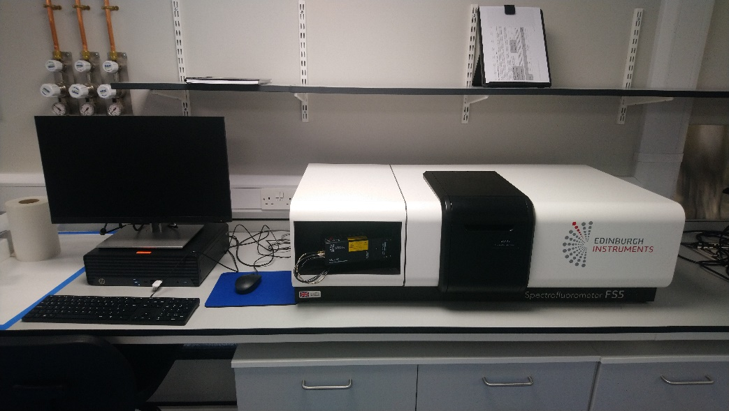

**Figure 4.** The Edinburgh Instruments FS5 Fluorescence spectrometer available in the ACIS lab.

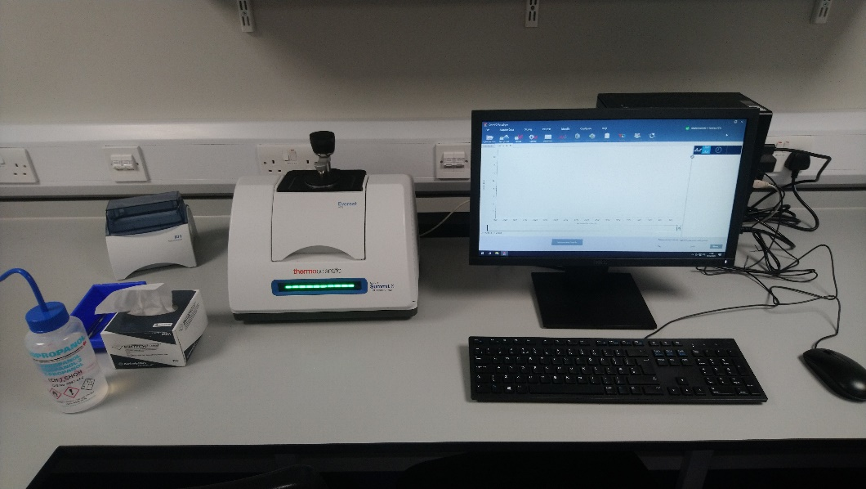

**Figure 5.** The Thermo Scientific Nicolet Summit X FTIR spectrometer available in the ACIS lab.

**Safety:**

Hazards associated with this exercise and the Fluorimeter and IR spectrometer are listed in the Risk Assessment Form available on LEARN.

The fluorimeter is fitted with a pulse LASER for lifetime measurements. Whilst the LASER is usually bolted to the instrument and protected by internal safety locks, it can technically be removed, and users must therefore complete the School LASER safety training **BEFORE** attending the lab.

The LASERs are not required for standard fluorescence measurements, but if required, they need turned on using a key. Please contact the ACIS instrument technician if you wish to carry out lifetime measurements in future.

**Instrument Walk-Through – Fluorimeter:**

1. **Instrument Overview:**

* Familiarize users with the components of the fluorimeter, including the sample chamber, LASER, excitation & emission filters and the software interface.
* Provide an overview of the theory behind fluorescence spectroscopy and the types of measurements that can be made.

2. **Safety Precautions:**

* Emphasise safety measures, including proper handling of solvents and chemicals.
* Provide guidelines for using personal protective equipment, such as lab coats and safety glasses.
* Confirm all users have completed the necessary LASER safety training.

3. **Powering On and System Check:**

* Demonstrate the proper sequence for turning on the instrument and time required to make sure the lamp and LASER are operating correctly.

4. **Sample Preparation:**

* Provide guidelines on choosing the appropriate solvents sample concentrations. The optical window of each solvent should be considered and absorbances kept below 0.1 A to avoid inner filter effects.
* Provide guidance on how to syringe filter samples to prevent any interference in the spectra.
* Provide guidance on correct cleaning procedures for the cuvettes. Rinse with a suitable solvent and dry with a lint free cloth. Clean thoroughly between samples and start with the lowest concentration is running calibration curves. Take care to handle cuvettes with gloves and hold them via the edges rather than faces where possible.

5. **Data Acquisition:**

* Instruct users on how to load samples into the holder and acquire blank spectra.
* Instruct users on how to set up and select an appropriate method including spectral width, slit widths, lamp switch over, number of data points, scan rate and any repetitions.
* Explain the difference between excitation and emission spectra.
* Discuss the use of excitation/emission filters and why they may be needed.

6. **Data Analysis:**

* Demonstrate how to interpret the spectra including peak maxima and total area.
* Discuss the presence of additional peaks including Raman/Rayleigh bands and second order diffraction.
* Explain how to export the data in multiple file formats.

7. **Shutdown Procedure:**

* Emphasize the importance of leaving the work area clean and tidy.
* Remind users to turn off the LASER if in use and return the keys to the ACIS instrument technician.

8. **Maintenance and Troubleshooting:**

* Offer guidance on common troubleshooting issues and when to contact the ACIS Instrument Technician. Common issues include non-zero baselines or excessive noise or interference due to dirty or contaminated samples. Significant non-linearity of emission intensity may also be observed for concentrated samples due to inner filter effects.

9. **Documentation:**

* Stress the importance of maintaining a detailed log of all fluorescence spectra, including method parameters, sample details, and obtained spectra. These details should all be recorded in lab notebooks and any data copied over to personal devices via a USB memory stick.

**Instrument Walk-Through – IR Spectrometer:**

1. **Instrument Overview:**

* Provide an overview of the principles of IR spectroscopy including the basics of IR absorption and bending/stretching modes.
* A discussion on the applications of IR spectroscopy including functional group identification and database matching.
* Explain the difference between transmission mode and Attenuated Total Reflectance (ATR).

2. **Safety Precautions:**

* Emphasise safety measures, including proper handling of solvents and chemicals.
* Provide guidelines for using personal protective equipment, such as lab coats and safety glasses.

3. **Powering On and System Check:**

* Demonstrate the proper sequence for turning on the instrument and time required to make sure the lamp is operating correctly.
* Explain how to clean the instrument and change the required module (ATR or transmission).

4. **Sample Preparation:**

* Provide guidelines on choosing the appropriate mounting for analysing different substances. For ATR, samples can be placed directly onto the sample stage.
* Provide guidance on how to select the most suitable head piece. Flat or concave for solids, rubber ring for liquids or volatile compounds.
* Provide guidance on correct cleaning procedures for the cuvettes. Rinse with a suitable solvent and dry with a lint free cloth. Clean thoroughly between samples and start with the lowest concentration is running calibration curves.

5. **Data Acquisition:**

* Instruct users on how to acquire blank spectra.
* Instruct users on how to set up and select an appropriate method including spectral width, number of data points, scan rate and any repetitions.

6. **Data Analysis:**

* Demonstrate how to interpret the spectra including suitable units and peak picking.
* Explain how to export the data in multiple file formats.

7. **Shutdown Procedure:**

* Emphasize the importance of leaving the work area clean and tidy.

8. **Maintenance and Troubleshooting:**

* Offer guidance on common troubleshooting issues and when to contact the ACIS Instrument Technician. Common issues include non-zero baselines or poor signal intensity due to not tightening the mount fully.

9. **Documentation:**

* Stress the importance of maintaining a detailed log of all IR spectra, including method parameters, sample details, and obtained spectra. These details should all be recorded in lab notebooks and any data copied over to personal devices via a USB memory stick.

**Test Samples:**

Test sample details – to be added.

**Assessment:**

Complete the associated multiple-choice quiz on LEARN.

**Further Support:**

The full instrument manuals are available on LEARN. You are not expected to read these in full, however, please use these as reference if you wish to know any more about the instruments or refresh your memory of how to operate them.

**Topic 4: Reitveld Refinement**

**Learning Outcomes:**

* Explain the

**Pre-lab:**

Please refer to LEARN for all of

**Introduction:**

Nuclear Magnetic Resonance Spectroscopy (NMR) is a powerful analytical technique used

**Safety:**

Hazards associated with this exercise and the NMR instruments are listed in the Risk Assessment Form available on LEARN.

**Assessment:**

Complete the associated multiple-choice quiz on LEARN.

**Further Support:**

Further information on the

**Computational Exercise**

**Learning Outcomes:**

* Understanding of the practical aspects of molecular simulations.
* Basics of the command-line interface and usage high-performance computing resources.
* Operating common computational chemistry packages to tackle real chemical problems.
* Preparation of systems for molecular dynamics simulations and troubleshooting the set up, simulations and analysis steps.
* Understanding of the limitations of the computational chemistry techniques used.
* Reporting of the methodology and observations in a condensed written format.
* Group working, encouraged and developed through the practicals.

Computational techniques have become an integral part of the research, with their importance and contribution to scientific discovery growing rapidly in recent years. The use of computational techniques in chemistry has made it possible to simulate chemical reactions and predict the properties of molecules with a high degree of accuracy. Additionally, molecular simulations have made it possible to study complex systems that are difficult, if not impossible, to study experimentally, such as large protein complexes, biological membranes, interactions of molecules and materials at the interface, processes in space or in extreme conditions. These methods have had a positive impact on society by accelerating the development of new drugs, materials, and technologies. Therefore, it is essential for students to have a solid understanding of computational techniques and their applications in modern scientific methods. This part of the course, focuses on molecular dynamics simulations, one of the most commonly used methodologies in current research.

**Content:**

Session 1: Introduction to Linux and command-line.

Session 2: Introduction to molecular dynamics simulations on a practical simulation of a protein.

Session 3: Molecular simulation set up of system with an interface.

Session 4: Beginning of the individual projects.

**All the materials for the sessions are provided on LEARN.**

**Drop-in sessions:**

Weekly drop-in sessions with demonstrators are scheduled for ….

**Assessment:**

Individual project with a short, written report. The report structure can be found on LEARN.**Investigation B: Synthesis and Evaluation of a High Tc Superconductor**

**1. Introduction**

The property of superconductivity has been known since 1911. Research in this field has led to applications of superconducting materials in areas such levitation (maglev trains), powerful magnets (Magnetic Resonance Imaging) and zero electrical resistance (power transmission over large distances without heating losses).

Thirty years ago, a discovery was made which revolutionised this property with the announcement that superconductivity had been observed at 90K in a ceramic material, YBa2Cu3O7-x (YBCO) (figure 1). This started research into “High Temperature Superconductors”, whereby enhancement of the property was targeted through modification of the composition. This study will investigate the synthesis, composition, structure and properties of the superconducting material YBCO.

|  |  |
| --- | --- |
| YBCO poly and bonds |  |
| Figure 1(a) the crystal structure of YBa2Cu3O7  (Y (grey), Ba (blue), Cu (red)) | Figure 1(b) The conductivity of YBa2Cu3O7 |

**2. Investigation Aims**

***Composition-structure-property relationships of the high Tc superconductor YBCO***

The aims of this investigation are:

* To prepare a sample of the high Tc superconductor YBCO
* To determine parameters for the optimisation of the properties of the high Tc superconductor YBCO
* To characterise the high Tc superconductor YBCO using a range of different materials characterisation techniques.
* To discuss composition-structure-property relationships of the high Tc superconductor YBCO.

Students will work in groups of 5 (group assignments will be made prior to the lab classes starting). You will be required to prepare one sample per student in the first week. After preliminary analysis you must then choose, within your group, one sample you wish to take forward for further treatment and more in-depth characterisation.

**3. Timetable**

Week 5

This week is set aside for planning and reading. Use this time to meet your group and discuss your project. Set out plans for how you plan to tackle the project and read the associated background information. The more prepared you are for the practical sessions, the more you will be able to get done.

Week 6

The first aim of the investigation is for each student to prepare a sample of YBCO. Determine the optimal parameters to synthesise a sample.

During the week 6 lab, a workshop on analysis of X-ray powder diffraction data will be carried out; this will cover using software to carry out structural analysis using XRPD data.

Week 7

Consider which characterisation method(s) to use to show whether the synthesis was successful. Decide in your group which sample will be characterised further. Consider whether you wish to carry out any further synthetic optimisation of the sample.

Weeks 8-10

Focus on characterisation of the sample. What are the characterisation methods that should be used to determine the structure, properties, and composition of the chosen YBCO sample? Plan in your groups, the use of different pieces of equipment. Discuss with the demonstrators booking and using the equipment.

The write up

Once complete, each student should write up and submit AN INDIVIDUAL REPORT BASED ON THE FINDINGS FROM EACH GROUP. The results from this investigation should be written up in the style of an RSC *Chemical Communications* article.

Compile and discuss the results from the structure, composition, and property measurements you have made. Compare your results with the other groups in the Materials Chemistry cohort. Include in your discussion, how the results are similar or different between the groups and what might influence these differences.

**4. Investigation Details**

Literature review/ background reading

To aid in planning for the experimental phase of this investigation, it is advised that students should read up on the following topics:

* Superconductivity
* Crystal Chemistry of copper oxide materials
* Structural characterisation of materials using powder diffraction data

This will help with both background understanding and preparation for writing the introduction section of the final report, which will be written in the style of a journal article, e.g. RSC Journal *Chemical Communications*)

Experiment planning

For you to complete this investigation, you will need to consider the following questions:

* What synthesis method to use?
* How to ensure the material is superconducting – what is the best method to achieve this? (extra marks given for best superconducting material).
* How to characterise the material?
* What methods will be used? What information will be achieved from each of the characterisation methods?
* How can this information be compiled to discuss composition-structure-property relationships of the superconducting phase YBCO.

Influence of synthesis conditions on the properties of YBCO

There are several different methods to synthesise YBCO. This project will focus on solid state methods, but through varying the conditions of synthesis the properties of YBCO can be altered. Research different possible conditions of synthesis and develop a synthetic strategy to optimise the properties of YBCO.

References

*Solid State Chemistry and its Applications,* A.R. West, Wiley, Second Edition, 2014, chapters 1, 5, 8

*Chemistry of Oxide Superconductors*, C.N.R. Rao, Blackwell, 1988

*Fundamentals of Powder Diffraction and Structural Characterization of Materials*, V. Pecharsky, P. Zavalij, Springer 2003

*Inorganic Materials Chemistry*, M.T. Weller, Oxford Primers, 1995, chapter 3

*A Review on the Synthesis of Y-Ba-Cu-oxide powder*, L.C. Pathak, S.K. Mishra, Supercon. Sci. and Technol., 2005, 18, R67-R89

**5. The Laboratory**

You will be based within the physical chemistry teaching lab for the synthesis and TGA analysis but will regularly make use of equipment in the ACIS lab and elsewhere in the building for further analysis of your samples in weeks 8-10.

You will be assigned a PhD Demonstrator to oversee your work, answer any questions you might have and ensure your safety whilst working within the laboratory. You can also contact the lab technician (Scott Moonie) if you require any assistance with additional chemicals or equipment.

**6. Available Analytical Techniques**

The School of Chemistry has a wealth of world class instruments and analytical facilities. You will have access to the following instrumentation and services to aid you in the identification and quantification of unknown substances.

Note that the collection of data for poorly prepared samples will not be tolerated due to the risk these samples might pose to the instruments. Take care to prepare samples according to guidelines and ask for assistance if in doubt.

The running of any spectroscopic samples should be cleared with your demonstrator beforehand to ensure that service time is being used appropriately. Your demonstrator will be able to offer advice on how to access/use appropriate services.

*X-ray Powder Diffraction:*

This can be used to identify the crystalline phase or phases present in a sample. Every crystalline material has a unique X-ray powder diffraction pattern. The data collected can be analysed by comparison with the Inorganic Center for Diffraction Data (ICDD) Powder Diffraction File (PDF), which house >500,000 X-ray powder diffraction patterns.

*IR Spectroscopy:*

This can be used to either identify a pure compound based on its IR fingerprint and known databases or quantify mixtures if IR spectra of individual components are known. However, for unknown compounds, its primary purpose is to identify functional groups.

*Thermal Analysis:*

There are several different techniques, for instance Differential Scanning Calorimetry (DSC) or Differential Thermal Analysis (DTA) can monitor phase changes as a function of temperature, whereas Thermogravimetric Analysis (TGA) monitors weight changes as a function of temperature. DSC is especially helpful in identifying polymer samples, whereas TGA can be helpful in analysing inorganic salts.

*Elemental Analysis:*

Determination of chemical formulae but usually used as a measure of compound purity,. There are a variety of chemical analysis techniques that materials chemists use. The sample can either be analysed as a solid using techniques such as X-ray Fluorescence (XRF) or dissolved and wet chemical analysis techniques used, such as Inductively Coupled Plasma Optical Emission Spectroscopy (ICP-OES).

*X-Ray Fluorescence Spectroscopy (XRF):*

Irradiation of samples with a high energy X-ray results in the emission of “secondary” X-rays from the material that give information about the elemental composition.

*Scanning Electron Microscopy (SEM):*

Scanning Electron Microscopy (SEM) is used for imaging of samples. Instead of using a beam of light to illuminate the sample, as in light microscopy, a beam of electrons is scanned across the surface of a sample. The electrons interact with the atoms in the sample and allow information about the surface topography as well as composition to be obtained. In comparison with light microscopy, much higher magnifications can be achieved and compositional information, due to elemental contrast, may be extracted from the images.

**6. Report Structure**

The report for this investigation will be submitted as a formatted paper in the standard Royal Society of Chemistry (RSC) journal format – specifically for the journal [Chemical Communications](https://pubs.rsc.org/en/journals/journalissues/cc#!recentarticles&adv). This gives you the opportunity to write out your results as you would do if submitting novel research for publication in a peer-reviewed journal. Appendix A below contains a version of the official journal template for reference, but you can download an editable version from LEARN or at the following website:

[https://www.rsc.org/journals-books-databases/author-and-reviewer-hub/authors-information/prepare-and-format/article-templates/#microsoftword](https://www.rsc.org/journals-books-databases/author-and-reviewer-hub/authors-information/prepare-and-format/article-templates/%23microsoftword)

Remember, the purpose of a scientific paper is to present a solution to an identified problem. You should present an aim or hypothesis, describe the experiments and results carried out, and discuss how the data either completes the aim or backs up the hypothesis.

You can find many examples of how to present your data by simply going to the Chemical Communications journal website and looking through some of the recent articles.

In line with the journal protocol, you should only present data directly related to the discussion within the main body of the paper. Any other extended experimental details (methods, additional spectra, calculations etc) should be provided within the Supporting Information. For the purposes of marking, you should combine your paper with the Supporting information into a single .pdf file before submission.

**FAQs**

1. **Who should I list as an author?**

Whilst you will be carrying out the work in groups, the report is still presented as a piece of individual work. You can simply list yourself as the only author.

1. **Is there a word limit for the report?**

There is no specific word limit for the paper, but is should be no more than 4 pages in length. The supporting information has no specific maximum length but it should only include information directly relevant to the paper’s content. Marks will be deducted for extended versions containing irrelevant results.

1. **Should I provide a graphical abstract?**

No, but you should include the standard written abstract within the template.

Received 00th January 20xx,

1. Address here.
2. Address here.
3. Address here.

† Footnotes relating to the title and/or authors should appear here.

Electronic Supplementary Information (ESI) available: [details of any supplementary information available should be included here]. See DOI: 10.1039/x0xx00000x

Accepted 00th January 20xx

DOI: 10.1039/x0xx00000x

**Title**

Author Full Name,*a Author Full Name b and Author Full Name c

Abstract here. The abstract should be a single paragraph which summarises the content of the article. It should be no longer than 50 words (approximately 5-6 lines).

The main text of the article should appear here. Headings and subheadings are not permitted in articles submitted to *Chemical Communications*, with the exception of “**Conflicts of interest**” and “**Notes and references**”. Headings are permitted in communications submitted to other journals.

**Conclusions**

The conclusions section should come in this section at the end of the article. Please remove the “**Conclusions**” heading for articles submitted to *Chemical Communications*.

**Author Contributions**

We strongly encourage authors to include author contributions and recommend using [CRediT](https://credit.niso.org/) for standardised contribution descriptions. Please refer to our general [author guidelines](https://www.rsc.org/journals-books-databases/journal-authors-reviewers/author-responsibilities/) for more information about authorship. Please remove the “**Author Contributions**” heading for articles submitted to *Chemical Communications*.

**Conflicts of interest**

In accordance with our policy on [Conflicts of interest](http://www.rsc.org/journals-books-databases/journal-authors-reviewers/author-responsibilities/#code-of-conduct) please ensure that a conflicts of interest statement is included in your manuscript here.  Please note that this statement is required for all submitted manuscripts.  If no conflicts exist, please state that “There are no conflicts to declare”.

**Notes and references**

‡ Footnotes relating to the main text should appear here. These might include comments relevant to but not central to the matter under discussion, limited experimental and spectral data, and crystallographic data.

§

§§

etc.

Citations should appear here in the format A. Name, B. Name and C. Name, *Journal Title*, 2000, **35**, 3523; A. Name, B. Name and C. Name, *Journal Title*, 2000, **35**, 3523.

…

We encourage the citation of primary research over review articles, where appropriate, in order to give credit to those who first reported a finding. [Find out more](https://www.rsc.org/news-events/articles/2020/jun/rsc-signs-dora/) about our commitments to the principles of San Francisco Declaration on Research Assessment (DORA).

Formatting – please delete this box prior to submission

* Our template aims to give you an idea of what your article will look like, however the final version will be formatted in our house style and may look different.
* Please consult the Styles menu for recommended formatting for all text, including footnotes, references, tables, images and captions.
* Text should not be wrapped around graphics.
* *Chemical Communications* has a four page limit, therefore following editing and production, your article may require shortening. To assist with this please do not alter font sizes from the Styles menu.

During production:

* Graphics, including tables, will be located at the top or bottom of the column following their first citation in the text. Graphics can be single column or double column as appropriate and require captions.
* Equations will be placed in the flow of the text.
* Sufficient space will be inserted around graphics for clarity of reading; a horizontal bar will also be used to separate all inserted graphics, tables and their captions from the text.

If you are experiencing difficulty using our template, please consult our ‘Using the Template’ guide, found [here](https://www.rsc.org/journals-books-databases/author-and-reviewer-hub/authors-information/prepare-and-format/article-templates/).